Title: Boundary Condition of Grounding Lines Prior to Collapse, Larsen-B Ice Shelf, Antarctica
Authors: M. Rebesco1*, E. Domack2,3, F. Zgur1, C. Lavoie1, 4, A. Leventer5, S. Brachfeld6, V. Willmott7, G. Halverson8, M. Truffer9, T. Scambos10, J. Smith11 E. Petit11
Affiliations:
1OGS (Istituto Nazionale di Oceanografia e di Geofisica Sperimentale), Borgo Grotta Gigante 42/C-34010, Sgonico (TS) Italy.
2Department of Geosciences, Hamilton College, Clinton New York USA 13323.
3College of Marine Science, University of South Florida, 140 7th Avenue South, St. Petersburg, Florida USA, 33701-5016.
4Department of Geosciences, University of Aveiro, Aveiro, 3810-052, Portugal.
5Department of Geology, Colgate University, Hamilton New York USA 13346.
6Department of Earth and Environmental Studies, Montclair State University, Montclair New Jersey USA 07043.
7Alfred Wegener Institute, Bremerhaven, Germany.
8Earth and Planetary Sciences, McGill University, Montreal, Quebec, Canada H3A 2A7.
9Geophysical Institute, University of Alaska Fairbanks, Fairbanks AK USA 99775.
10National Snow and Ice Data Center, University of Colorado, Boulder CO USA 80309.
11British Antarctic Survey, Cambridge UK CB3 0ET.
12Department of Geosciences, 900 Yukon Drive, Room 308, Post Office Box 755780, University of Alaska.

* Corresponding to: mrebesco@ogs.trieste.it.

Abstract:
Grounding zones, where ice sheets transition between resting on bedrock to full floatation, help regulate ice flow. Exposure of the seafloor by the 2002 Larsen-B Ice Shelf collapse allowed detailed morphologic mapping and sampling of the embayment sea floor.Marine geophysical data collected in 2006 reveal a large, arcuate, complex grounding zone sediment system at the front of Crane Fjord. Radiocarbon-constrained chronologies from marine sediment cores indicate loss of ice contact with the bed at this site about 12,000 years ago. Previous studies and morphologic mapping of the fjord suggest that the
Crane Glacier grounding zone was well within the fjord before 2002 and did not retreat further until after the ice shelf collapse. This implies that the 2002 Larsen-B Ice Shelf collapse likely was a response to surface warming rather than to grounding zone instability, strengthening the idea that surface processes controlled the disintegration of the Larsen Ice Shelf.

One Sentence Summary: Retreat of the Larsen Ice Shelf grounding line was complete 12 ka indicating recent disintegration was associated with surface climate, not oceanographic forced instability.
Main Text:
Our ability to model or predict changes in marine-based glaciers or ice sheets due to rising sea level and warming temperatures is severely limited by an inadequate understanding of the morphology and temporal behavior of ice shelf/ice sheet grounding zone systems (GZS) (1-3). While temperature changes (of both lower atmosphere and seawater) force changes in ice mass transfer to the oceans (4), the removal of ice shelf buttresses are also critical in regulating subsequent glacier response (5-7). Between January to March 2002, the Larsen B Ice shelf catastrophically collapsed, with a loss of ~2500 km² of floating ice (8). One of the most important discoveries made following the collapse of the Larsen Ice Shelf was the dramatic flow acceleration of tributary glaciers that at one time fed into the ice shelf system—including the Crane, Hektoria, and Drygalski Glaciers (5-7). Following this was the rapid, in some cases extensive, recession of the calving line of these newly formed tidewater fronts (9). Such observations revive the thinking that linkages between grounded glaciers and ice shelves are indeed critical, more so than recently assumed (10), but attempts to understand this dynamic are limited by a lack of knowledge about the characteristics of the GZS.
Our bathymetry data image the inner shelf that was exposed following the ice shelf collapse (Fig. 1). The extensive arcuate GZS at the entrance to Crane Trough is a large prism seaward of the topographic divide at the mouth of the Crane Trough, which has a variable depth between 690 and 660 m. The grounding zone to the south appears to run parallel to a terrace at 600 m depth while to the north its expression into the drainage of the Jorum/Punchbowl system is far less clear due to the steep crystalline bedrock slope that dominates the headland (11). This prism tapers relatively gently seaward and becomes progressively steeper landward. Elongated ridges sub-parallel to the axis of the fjord, similar to subglacial lineations observed elsewhere on the Antarctic margin (12, 13) are interpreted as fluted subglacial bedforms (e.g., mega-scale lineations and/or flutes). A series of furrows curve toward the southeast as a result of the ice flow from the Jorum/Punchbowl system and a central pad of fluted sediment marks the central axis of Crane Trough. A set of relict channels (in an irregular pattern of salients and reentrants) also appears to crosscut the arcuate furrows on both the lee and stoss side of the GZS. These features collectively mark episodes of decoupling from the GZS beginning with the formation of the arcuate ridges, followed by cross-cutting of channels, and then deposition of the central fluted pad of sediment.
Well-dated sediment cores from the Larsen B embayment address the question of whether this GZS served to anchor the Larsen B Ice Shelf (LIS-B) prior to its 2002 collapse. NBP0603 KC-10 was recovered from the top of the GZS. The boundary between the diamicton (Unit 1) and the overlying sediments dates back at least 11,000 years (see Fig. 2 and Supplementary Note), indicating that this GZS was abandoned at termination I. The timing of glacial ice liftoff is supported further by a radiocarbon-based chronology from NBP0603 KC-5, where the same stratigraphy was observed (Figs. 2, 3). These observations of the GZS do not agree with the location of the grounding zone as inferred from satellite images (14), and the sediment core data reveal that glacial ice was not grounded here immediately prior to the 2002 LIS-B collapse. The reason for the misplacement of the grounding line by (14) is unclear, but thick floating ice inside a relatively narrow channel would exhibit reduced tidal bending, as would have been the case with Crane Glacier at this time. It is possible that a rift in this area would mimic the appearance of a grounding line. The abandonment of the large GZS relatively early with respect to Holocene events (prior to 11.7 ka) suggests that retreat of grounded ice within the Larsen B embayment was driven by processes similar to those which drove shelf-wide recession across the NW Weddell Sea continental shelf (i.e. 15). We suggest that this innermost retreat into the deep troughs of the Nordensköld Coast was tied to late stages of global eustatic forcing coupled to retreat of global glacial cover. The sedimentology and facies relationships of sediment cores just seaward of the Crane Trough (in Exasperation Inlet) demonstrate a rapid recession of the ice sheet system across the inner shelf which occurred 12.5 ka (Figs. 2, 3 and Supplementary Fig. 1). The chronologic data we present (Supplement), combined with existing published data further seaward (11), establish recessional rates of the grounding line within the main axis of the trough of ~100 m/year during the period from 12.3 to 11.7 ka. This compares favorably with ice sheet/shelf recessional rates obtained for the same period in the western Ross Sea (16).
Given these observations, the geophysical data, combined with ASTER imagery, can be used to determine the location of the pre-collapse grounding line in the Larsen embayment (Fig. 1). The Crane Glacier trough itself consists of three very deep (over 1000 m) and narrow (about 1 km wide) elongated basins separated by more elevated crests, each one representing the threshold of the upslope basin. The morphology of these thresholds shows the presence of mega-scale glacial lineations (MGSL) sub-parallel to the axis of the fjord. We interpret this morphology as the result of deposition of till beneath grounded ice. On Arctic continental margins, the same interpretation is given to similar associations of thresholds and MSGL (17). The fact that the ice was grounded in the fjord is confirmed by the seismic profile of the fjord, whose landward overdeepening and stairway geometry between its three basins, typical of glacial erosion landforms (18), can be explained best by the carving action of ice. The 2001 ASTER DEM profile locates the pre-collapse grounding zone of the Crane Glacier portion of the LIS-B at the threshold between the upper and the middle basin, over 13 km from the large GZS described above (Fig. 1b). The stability of the LIS-B through the Holocene (11) thus was not dependent on grounding at a large GZS; instead, collapse was forced by surface melt processes (6). Our data also reveal that the grounded base of the former Crane Glacier was over 700 me deeper than previously estimated on the basis of airborne echo-sounder data (10). This discovery suggests that the amount of ice discharged following the retreat of the Crane Glacier (and likely also of other similar tributary glaciers) has been underestimated by a factor of two or three (19). Estimates of the loss of ice from the Antarctic Peninsula as a whole (20) may therefore need to be adjusted as ice fronts continue to recede (21).
The floor of the basins shows a flat morphology, typical of a subsequent sedimentary filling under subaqueous conditions. Well-layered, undisturbed sediments extend for at least 40 m below the lower (outermost) basin (Fig. 4). This thickness is exceptional for an inner shelf deposystem that has been covered by an Antarctic glacier until only a few years ago (22). Single-channel seismic data show that the layered fill is underlain by another seismic unit of variable thickness and complex geometry (Fig. 4). In the dip profile, this unit is wedge-shaped, with its top sloping rapidly landward – beneath the middle basin and subsequently seaward dipping beneath the layered fill of the lower basin. Internally, it shows mounded, low amplitude reflectors terminating landward with marked downlap and prograding seaward. In the strike profile the sediments at the base of this unit have a relatively high sound velocity of about 1700 m/s as indicated by the analysis of the diffraction hyperbolas that severely affected the raw data. The lowest identified unit is more complex, poorly defined and characterized by hummocky, irregular, high-amplitude reflectors. Its top shows alternating ridges and troughs in the strike profile, which match the morphology of the thresholds between the basins.
The geometry, internal facies and velocities, and stratigraphic relationships of the seismic units allow us to reconstruct the relative succession of events that generated the sedimentary deposits within the Crane Fjord. Similar to other overdeepened basins on the Antarctic inner shelf (23), this fjord has been carved, likely along structural lines of weakness, by grounded ice. The last time the ice was grounded within the fjord is represented by the top of the lowest identified unit (Fig. 4). Its geometry of alternating troughs and ridges matches subglacial bedforms exposed across adjacent thresholds. Furthermore, the hummocky character of underlying reflectors is consistent with the deposition of subglacial till at the base of grounded ice. Conversely, the overlying wedge-shaped unit suggests the development of a grounding zone, beyond which a body of water separated the base of the ice from the seafloor. Its geometry and the internal prograding reflectors resemble those of subglacial deltas identified elsewhere along Antarctic grounding zones (23). This delta may have developed in a “subglacial lake” setting similar to that inferred for the subglacial deltas in the Northern Prince Gustav Channel (12) and the Palmer Deep basin (22, 24).
The overlying layered unit was clearly deposited subaqueously. Core KC-8 collected near the intersection of profiles 04 and 06 (Figs. 1, 3) suggest that the uppermost sediments resulted from the accelerated ice discharge (rafting) from the Crane Glacier following the break-up of LIS-B and seasonal slumping of debris along the flanks of the Crane Fjord (Fig. S2). This 2.7 m core shows clear meter-scale grain-size cyclicity between a fine silt facies virtually devoid of sand and a sandy silt facies (sand fraction up to over 50%), Fig. 2). The presence of well-preserved valves of diatom species commonly associated with the sea ice environment suggests the entire 2.7 m thick sequence was deposited in open marine conditions with annual sea ice (i.e., not sub ice shelf) – conditions known to have been present only since austral summer 2002-03 (3 years prior to core recovery). The diatoms are dominated by species of Fragilariopsis that are associated with sea ice and the marginal ice zone, primarily Fragilariopsis curta, F. sublinearis and F. vanheurckii, as well as colonies that can be identified only to the genus level; in general Fragilariopsis comprise >80% of the diatom assemblage and in half of the samples this genus comprises >90% of the diatom assemblage. The remainder of the assemblage is composed of lower percentages (a few percent each) of several species, including (but not restricted to) Actinocyclus actinochilus, Chaetoceros, Stellarima microtrias, and Thalassiosira gracilis (Supplementary Table 2 and 3). Preservation is excellent, with many very lightly silicified specimens occurring in ribbon colonies containing chloroplasts. While diatoms can be advected underneath ice shelves (25), published data indicate that advection of diatoms has not been observed beneath the Larsen B Ice Shelf (11, 26) where a post-breakup exponential increase in diatom abundance in the sediments has been documented. Data from the cores presented in this paper as well suggest the absence of advection of diatoms underneath the Larsen B Ice Shelf, as these cores also document the opening of the Larsen B embayment and the associated increase in diatom abundance, and the lack of diatoms below the uppermost part of the cores, except in NBP0603 KC08. The pristine condition of the frustules in the diatom-bearing intervals, which coincide with high water content and generally finer grain size, point to the very recent and rapid deposition of the valves at the sea floor, and very limited transport distances. This core is interpreted to represent just over one year of deposition (from austral summer 2004-05 to the end of the austral summer 2005-06), with an extraordinary sedimentation rate of about 2 m/year (Figs. 4 and S2). The sandy intervals are interpreted as summer turbidites, deposited when open water and surface melt would contribute to slope instabilities along the walls of the fjord and within the glacier terminus system (Figs. 2, 3 and S2).
Downward extrapolation of the ~ 2 m/year sedimentation rate estimated from core KC-08 suggests that only the uppermost ~ 6 meters of sediments in the lower basin were deposited after LIS-B breakup, corresponding to the layered reflectors (“recent fill”) identified in the seismic reflection data (Figs. 3, 4). The remainder of the sediments imaged in the lower basin, ~ 35 meters thick, may correspond to a sequence of turbidites deposited landward of the grounding zone represented by the threshold between the middle and lower basin, as observed in other grounding zone proximal sites (27). The ponded morphology and acoustic stratification of the sediments support this interpretation (Figs. 1, 4). The middle basin likely contains a sediment sequence similar to that observed in the lower basin; however, we have no chronologic control on the timing of the liftoff of ice at the threshold dividing the middle and lower basin. In its position landward of the 2001 grounding zone (Fig. 1), the deep upper basin may have existed as a subglacial lake through the Holocene (19).
As estimates for projected sea level rise over the next century continue to be revised from recent IPCC forecasts, the stability of GZS need further evaluation. Relict GZS now observed from several offshore troughs on the Antarctic continental shelf record a time of extreme rates of sea level change in the Quaternary (e.g. 22, 28, 29). As the global ocean approaches these past rates, increased attention must be focused upon the nature of grounding zone systems. The stability of the Larsen B Ice Shelf through the Holocene and its recent rapid collapse suggest strong sensitivity to surface warming.

References and Notes:
1. R. B. Alley, P. U. Clark, P. Huybrechts, I. Joughin, Ice-sheet and sea-level changes. Science 310, 456-460 (2005).
2. E. C. King, R. C.A Hindmarsh, C.R Stokes, Formation of mega-scale glacial lineations observed beneath a West Antarctic ice stream. Nat. Geosci. 2, 585-588 (2009).
3. M. Oppenheimer, Global warming and the stability of the West Antarctic ice sheet. Nature 393, 325-332 (1998).
4. S. Anandakrishnan, G. A. Catania, R. B. Alley, H. J. Horgan, Discovery of till deposition at the grounding line of Whillans Ice Stream. Science 315, 1835-1838 (2007).
5. E. Rignot, et al., Accelerated ice discharge from the Antarctic Peninsula following the collapse of Larsen B ice shelf. Geophys. Res. Lett. 31, L18401 (2004).
6. T. A. Scambos, J. A Bohlander, C. A. Shuman, P. Skvarca, Glacier acceleration and thinning after ice shelf collapse in the Larsen B embayment, Antarctica. Geophys. Res. Lett. 31, L18402 (2004).
7. P. Skvarca, , H. De Angelis, A. F. Zakrajsek, Climatic conditions, mass balance and dynamics of Larsen B ice shelf, Antarctic Peninsula, prior to collapse. Ann. Glaciol. 39, 557-562 (2005).
8. T. Scambos, C. Hulbe, M. Fahnestock, Climate-induced ice shelf disintegration in the Antarctic Peninsula. in Antarctic Peninsula Climate Variability: Historical and Paleoenvironmental Perspectives, E. Domack, A. Burnett, A. Leventer, P. Conley, M. Kirby, R. Bindschadler, Eds., Antarctic Research Series, 79, 79-92 (2003).
9. C. L., Hulbe, T. A. Scambos, T. Youngberg, A.K. Lamb, Patterns of glacier response to disintegration of the Larsen B ice shelf, Antarctic Peninsula. Global Planet. Change 63, 1-8 (2008).
10. E. Rignot, Changes in ice dynamics and mass balance of the Antarctic ice sheet. Philos. T. Roy. Soc. London Ser. A 364, 1637-1655 (2006).
11. E. Domack, et al., Stability of the Larsen B ice shelf on the Antarctic Peninsula during the Holocene epoch. Nature 436, 681-685 (2005). See cover photo of issue.
12. M. Canals, R. Urgeles, A. M. Calafat, Deep sea-floor evidence of past ice streams off the Antarctic Peninsula. Geol. 28, 31-34 (2000)
13. A. Camerlenghi, et al., Glacial morphology and post-glacial contourites in northern Prince Gustav Channel (NW Weddell Sea, Antarctica). Mar. Geophys. Res. 22, 417-443 (2001).
14. W. Rack, H. Rott, Pattern of retreat and disintegration of the Larsen B ice shelf, Antarctic Peninsula, Ann. Glaciol. 39, 505-510 (2004).
15. J. Evans, C. J. Pudsey, C. O’Cofaigh, P. Morris, E. W. Domack, Late Quaternary glacial history, flow dynamics and sedimentation along the eastern margin of the Antarctic Peninsula Ice Sheet. Quaternary Sci. Rev. 24, 741-774 (2005).
16. E. W. Domack, E. A. Jacobson, S. S. Shipp, J. B. Anderson, Late Pleistocene/Holocene retreat of the West Antarctic Ice Sheet in the Ross Sea: Part 2 – sedimentologic and stratigraphic signature. Geol. Soc. Am. Bull. 111, 1517-1536 (1999).
17. M. Rebesco, et al., Deglaciation of the western margin of the Barents Sea Ice Sheet - A swath bathymetric and sub-bottom seismic study from the Kveithola Trough. Mar. Geol. 279, 141-147 (2011).
18. D. E. Sugden, B. S. John, Glaciers and Landscape: A Geomorphologic Approach (Edward Arnold, London, 1976).
19. T. A., Scambos, E. Berthier, C. A. Shuman, The triggering of sub-glacial lake drainage during rapid glacier drawdown: Crane Glacier, Antarctic Peninsula. Ann. Glaciol. 52, 74-82 (2011).
20. E. Rignot, et al., Recent Antarctic ice mass loss from radar interferometry and regional climate modeling. Nat. Geosci. 1, 106-110 (2008).
21. A. J. Cook, , A. J. Fox, D. G. Vaughan, J. G. Ferrigno, Retreating glacier fronts on the Antarctic Peninsula over the past half-century. Science 308, 541-544 (2005).
22. E. Domack, et al., Subglacial morphology and glacial evolution of the Palmer Deep outlet system, Antarctic Peninsula. Geomorphology 75, 125-142 (2006).
23. J. B. Anderson, The Antarctic continental shelf: results from marine geological and geophysical investigations, in The Geology of Antarctica, R. J. Tingey, Ed. (Clarendon Press, Wotton-under-Edge, 1991), pp. 285-334.
24. M. Rebesco, A. Camerlenghi, L. De Santis, E. Domack, M. Kirby, Seismic stratigraphy of Palmer Deep: A fault-bounded late Quaternary sediment trap on the inner continental shelf, Antarctic Peninsula Pacific margin. Mar. Geol. 151, 89-110 (1998).
25. A. L. Post, M. A. Hemer, P. E. O'Brien, D. Roberts, M. Craven, History of benthic colonisation beneath the Amery Ice Shelf, East Antarctica. Mar. Ecol. Prog. Ser. 344, 29-37 (2007).
26. E. Sane, E. Isla, M. A. Barcena, D. DeMaster, D., A shift in the biogenic silica of sediment in the Larsen B continental shelf, off the eastern Antarctic Peninsula, resulting from climate change, PLoS One 8, e52632. doi:10.1371/journal.pone.0052632 (2013).
27. E. W. Domack, S. E. Ishman, Oceanographic and physiographic controls on modern sedimentation within Antarctic fjords. Geol. Soc. Am. Bull. 105, 1175-1189 (1993).
28. K. McMullen, et al., Glacial morphology and sediment formation in the Mertz Trough, East Antarctica. Palaeogeogr, Palaeocl. 231, 169-180 (2006).
29. J. B. Anderson, Ice Sheet Stability and Sea-Level Rise. Science 315, 1803-1804 (2007).
30. R. P. Scherer, A new method for the determination of absolute abundance of diatoms and other silt-sized sedimentary particles. J. Paleolimnol. 12, 171-179 (1994).
31. P. J. Reimer, et al., IntCal09 and Marine09 radiocarbon age calibration curves, 0–50,000 years cal BP. Radiocarbon 51, 1111–1150 (2009).
32. E. W. Domack, P. T. Harris, A new depositional model for ice shelves, based upon sediment cores from the Ross Sea and the MacRobertson shelf, Antarctica. Ann. Glaciol. 27, 281–284 (1998).
Acknowledgments: We thank the shipboard participants, captain, and crew of cruises NBP0603 and LMG0502 and the staff at the Antarctic Marine Geology Research Facility, Florida State University. This project was supported by grants from the NSF–Office of Polar Programs (0732467 to E.D.; 0732625 to A.L.; 0732605 to S.B.) and from Italian Programma Nazionale di Ricerche in Antartide project ULISSE. The data reported in this paper are tabulated in the supplementary materials. M.R. collected and interpreted seismic reflection data aboard cruise NBP0603 and assisted with writing major portions of the manuscript. E.D. supervised collection of field data and sedimentologic core data for cruises LMG0502 and NBP0603, wrote major portions of the paper, and drafted Figs. 2and 3. F.Z. collected, processed, and interpreted seismic reflection data aboard cruise NBP0603 and wrote sections of the paper dealing with interpretation of the reflection data. C.L. processed multibeam data, drafted Fig. 1, and wrote sections of the paper dealing with multibeam data. A.L. helped collect data aboard LMG0502 and NBP0603, analyzed diatom abundance data, and wrote sections of the paper dealing with diatom abundance and interpretation. S.B. helped collect data aboard NBP0603, collected and analyzed magnetic susceptibility data, and wrote sections of the paper dealing with physical properties of sediment cores. V.W. assisted in collecting sediment cores during LMG0502, collected color images of sediment cores during this cruise, and helped to draft portions of Fig. 2. G.H. assisted in collecting sediment cores during NBP0603, provided color images of sediment cores collected in this cruise, and helped with editing the manuscript. M.T. imported air geophysical data for interpretation of longitudinal profile of the Crane Glacier and provided editing of the manuscript. T.S. imported remote sensing data and interpretation of grounding line fluctuation before and after ice shelf collapse and assisted in writing and editing the paper. J.S. participated in collecting sediment cores and other data during LMG0502 and assisted in writing and editing the paper. E.P. was instrumental in the extensive discussion related to supplemental material dealing with ice terraces and morainal debris.
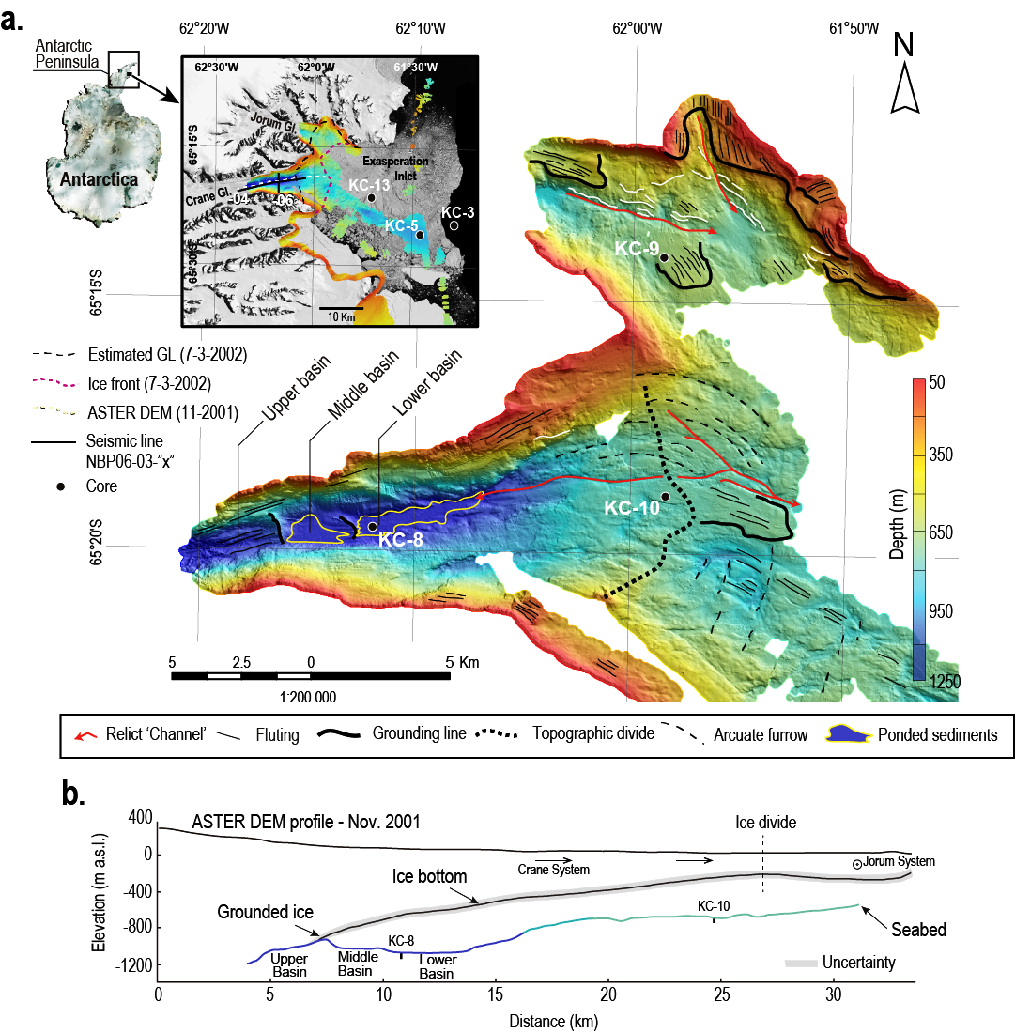

Fig. 1. Grounding zone system of Crane and Jorum glaciers. A) Processed and interpreted multibeam shaded relief bathymetric map of the Crane and Jorum troughs. Inset shows satellite (LIMA) image, location of the ASTER DEM profile (Fig. 1B), seismic tracklines illustrated in figure 4, location of cores KC-5, 8, 9, 10, and 13 (Figs. 2 and 3), indicated by black dots, and bathymetry of the area. B) ASTER DEM profile of the Larsen B Ice Shelf just prior to its breakup, and the underlying bathymetry derived from the multibeam data. Note that prior to collapse of the ice shelf in 2002, the ice is grounded just landward of the middle ponded basin.

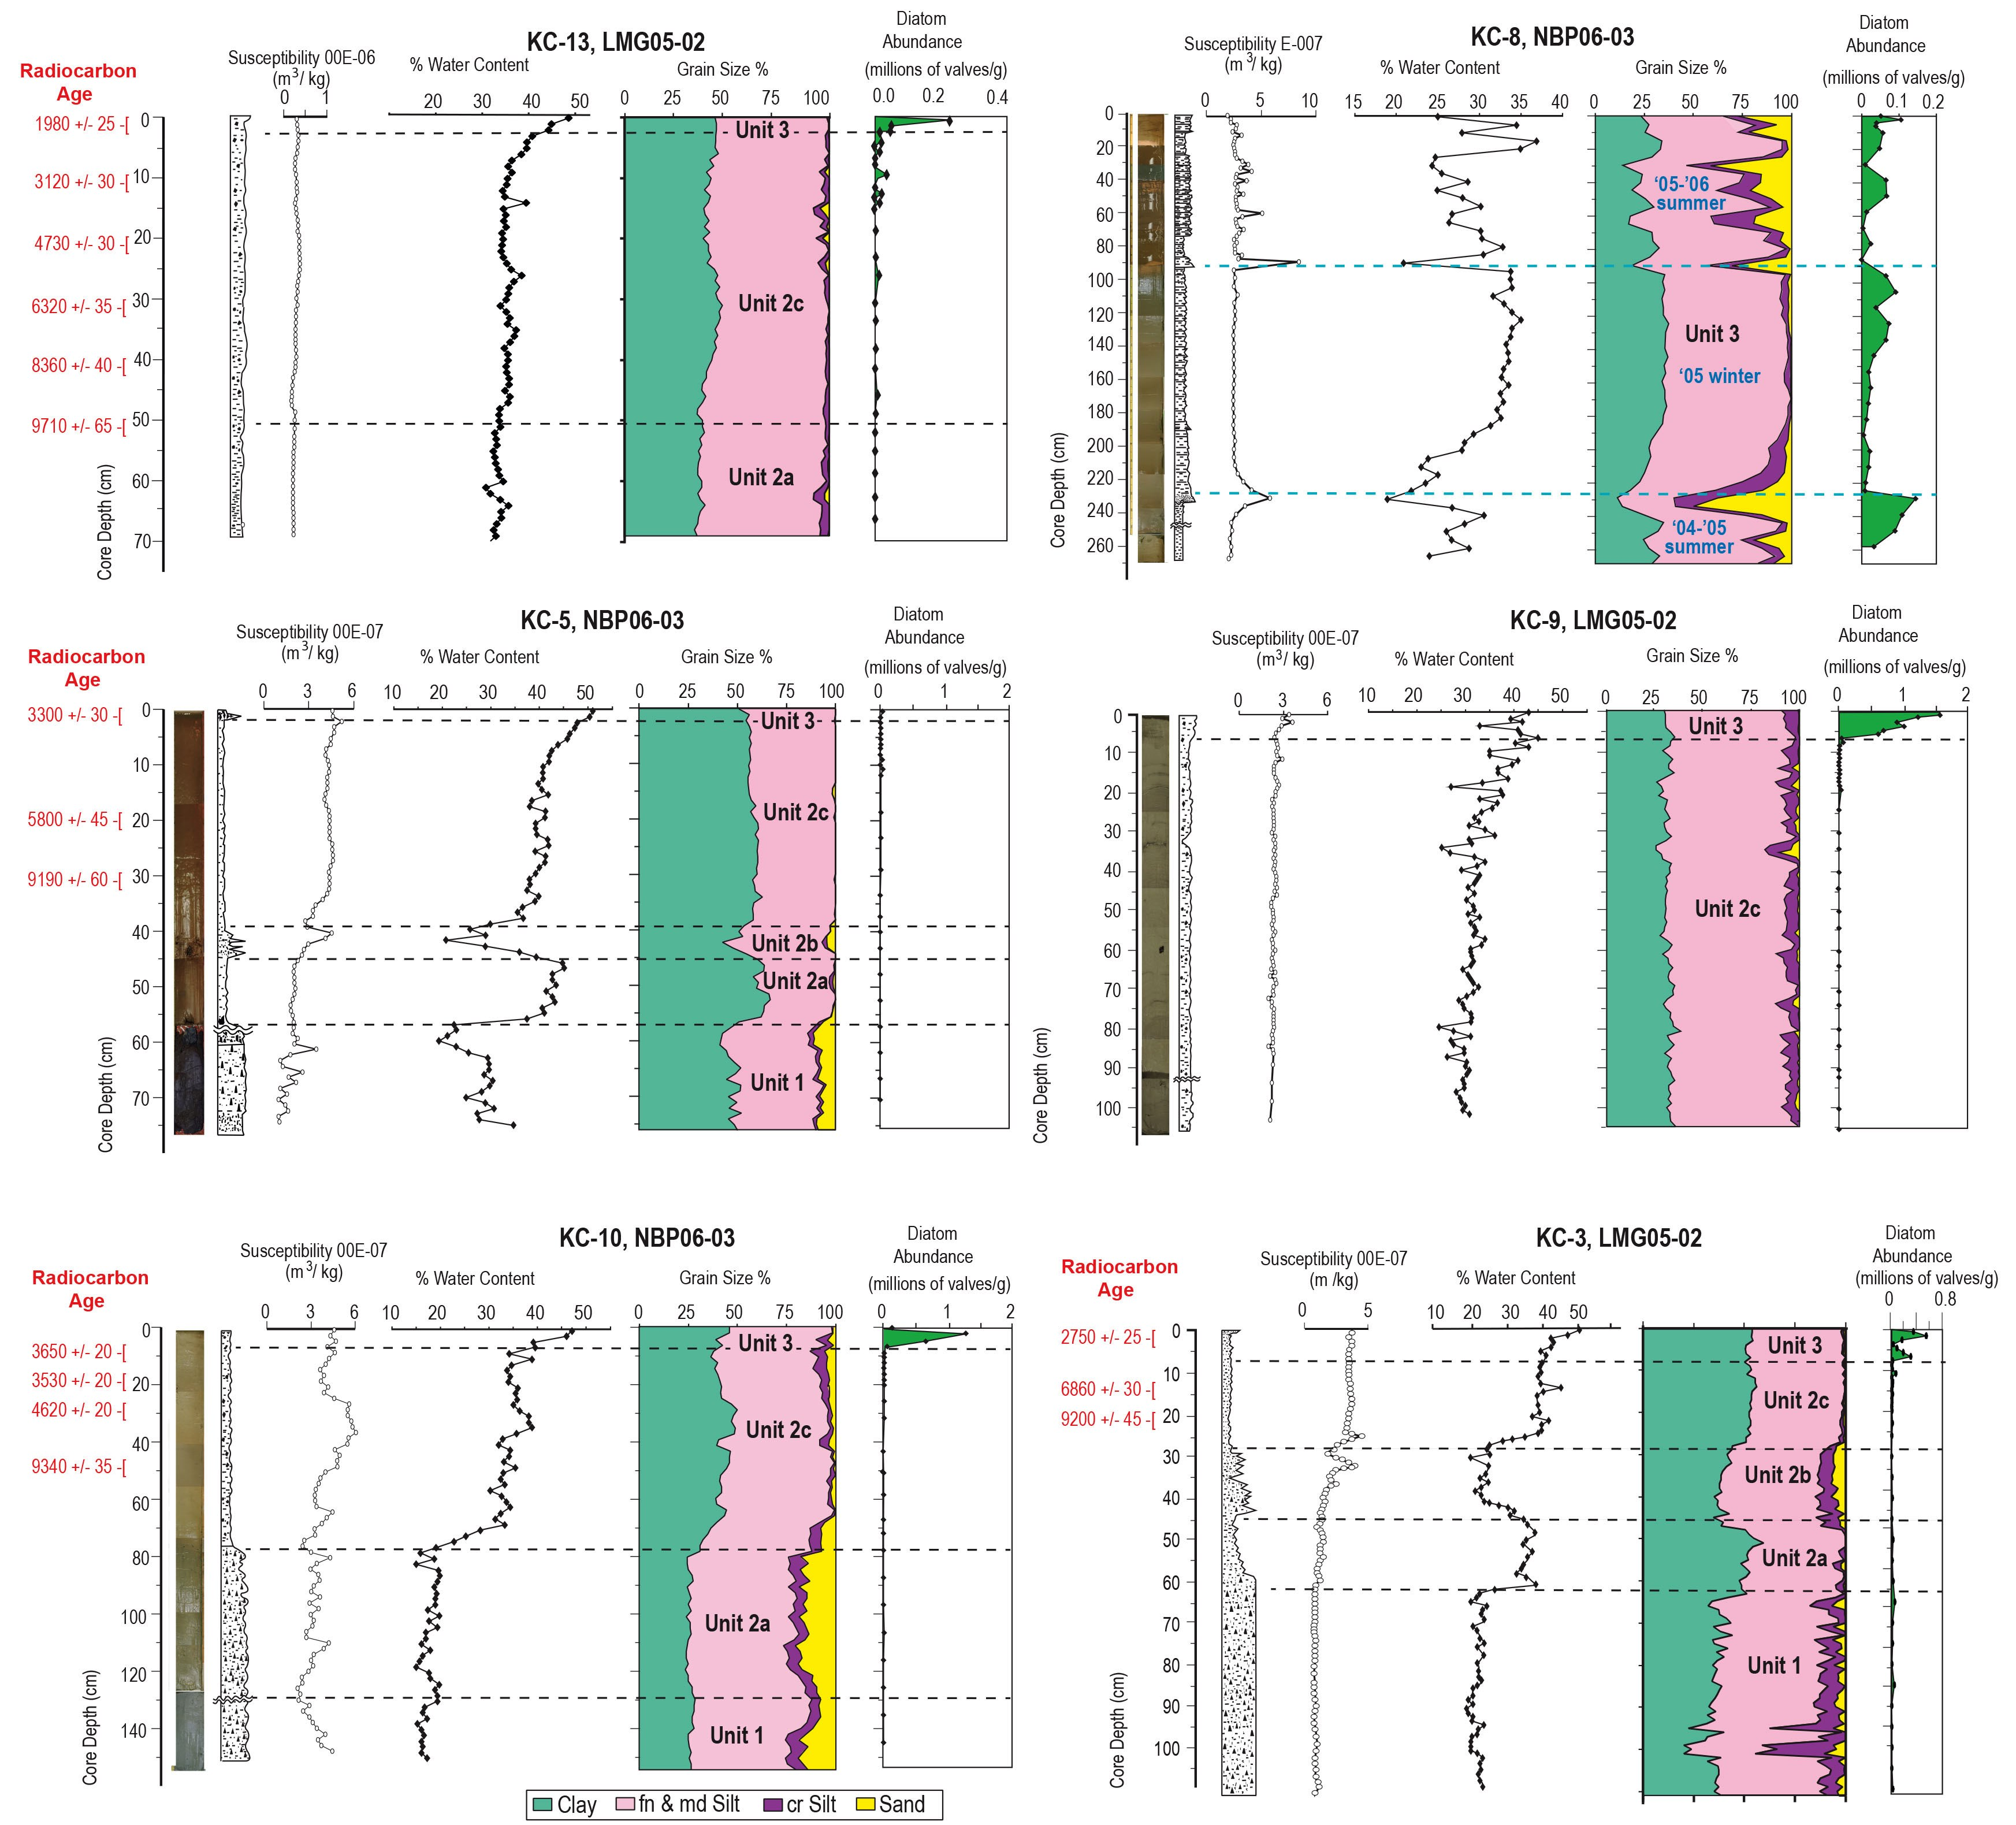

Fig. 2. Photographs, lithofacies, physical properties, and diatom abundance for six kasten cores collected in the vicinity of the Crane Trough (located in Fig. 1). Unit designations are as follows: Unit 1 is glacial diamicton (till) related to ice sheet (ice stream) grounding upon seafloor, Unit 2 is sub ice shelf sediment related to near (proximal) grounding line (2a), distal to grounding line (2c) and an, as yet, undetermined coarse interval (2b), Unit 3 represents the seasonal open marine facies formed since the break-up of the Larsen B ice shelf. Uncorrected radiocarbon dates on foraminiferal calcite (Supplementary Table 1) are indicated in red.

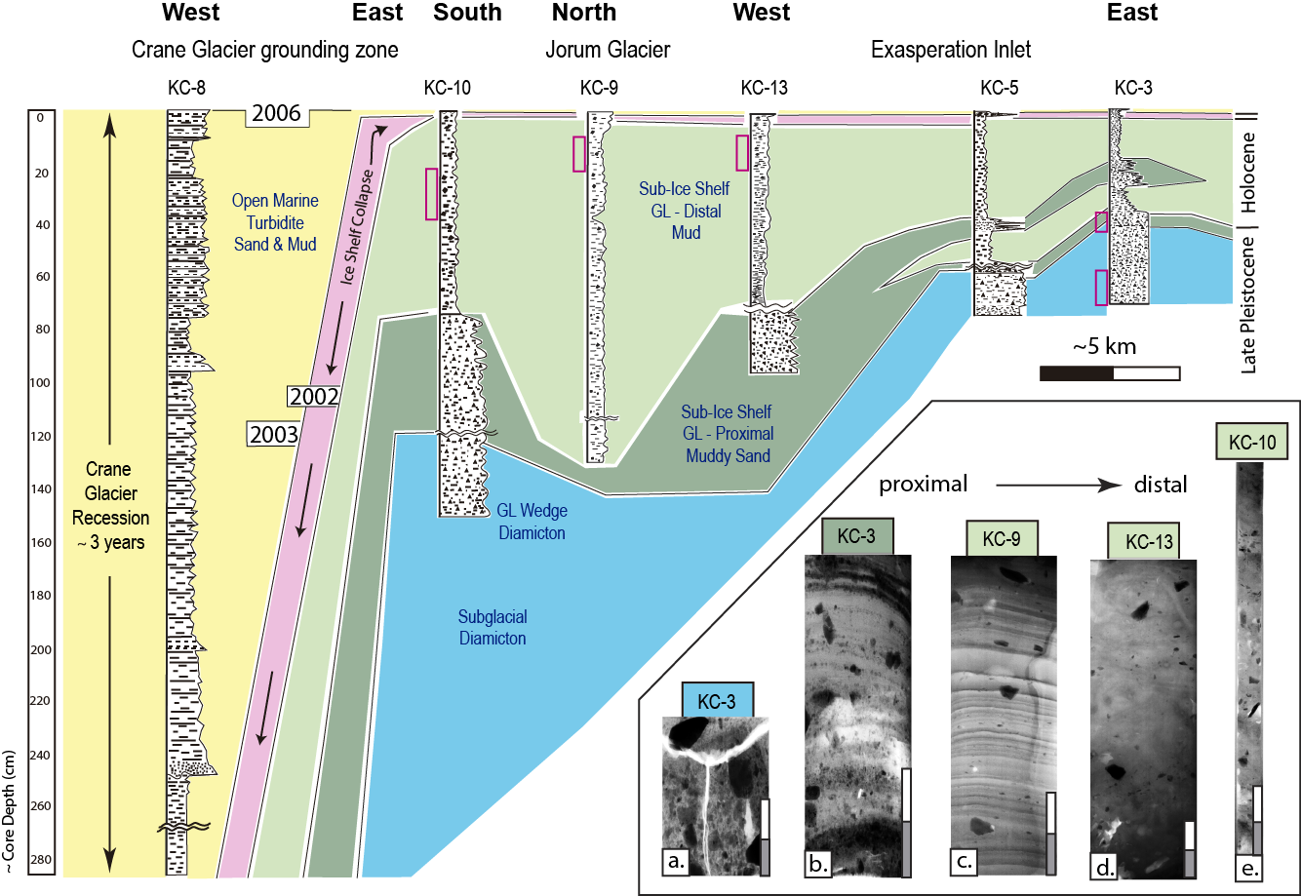

Fig. 3. Fence diagram of core sites and stratigraphic model across the grounding line wedge with sequence of events related to collapse of LIS-B. Facies correlation among cores is shown with color scheme where GL = grounding line. Inset illustrates x-ray radiograph positives (clasts are opaque) of specific facies intervals in selected cores where red rectangles next to each core indicate position of each x-ray radiograph (scale bar = 5 cm). Proximal to distal positions relative to grounded ice are shown for the sequence of x-ray radiographs as left to right, respectively.

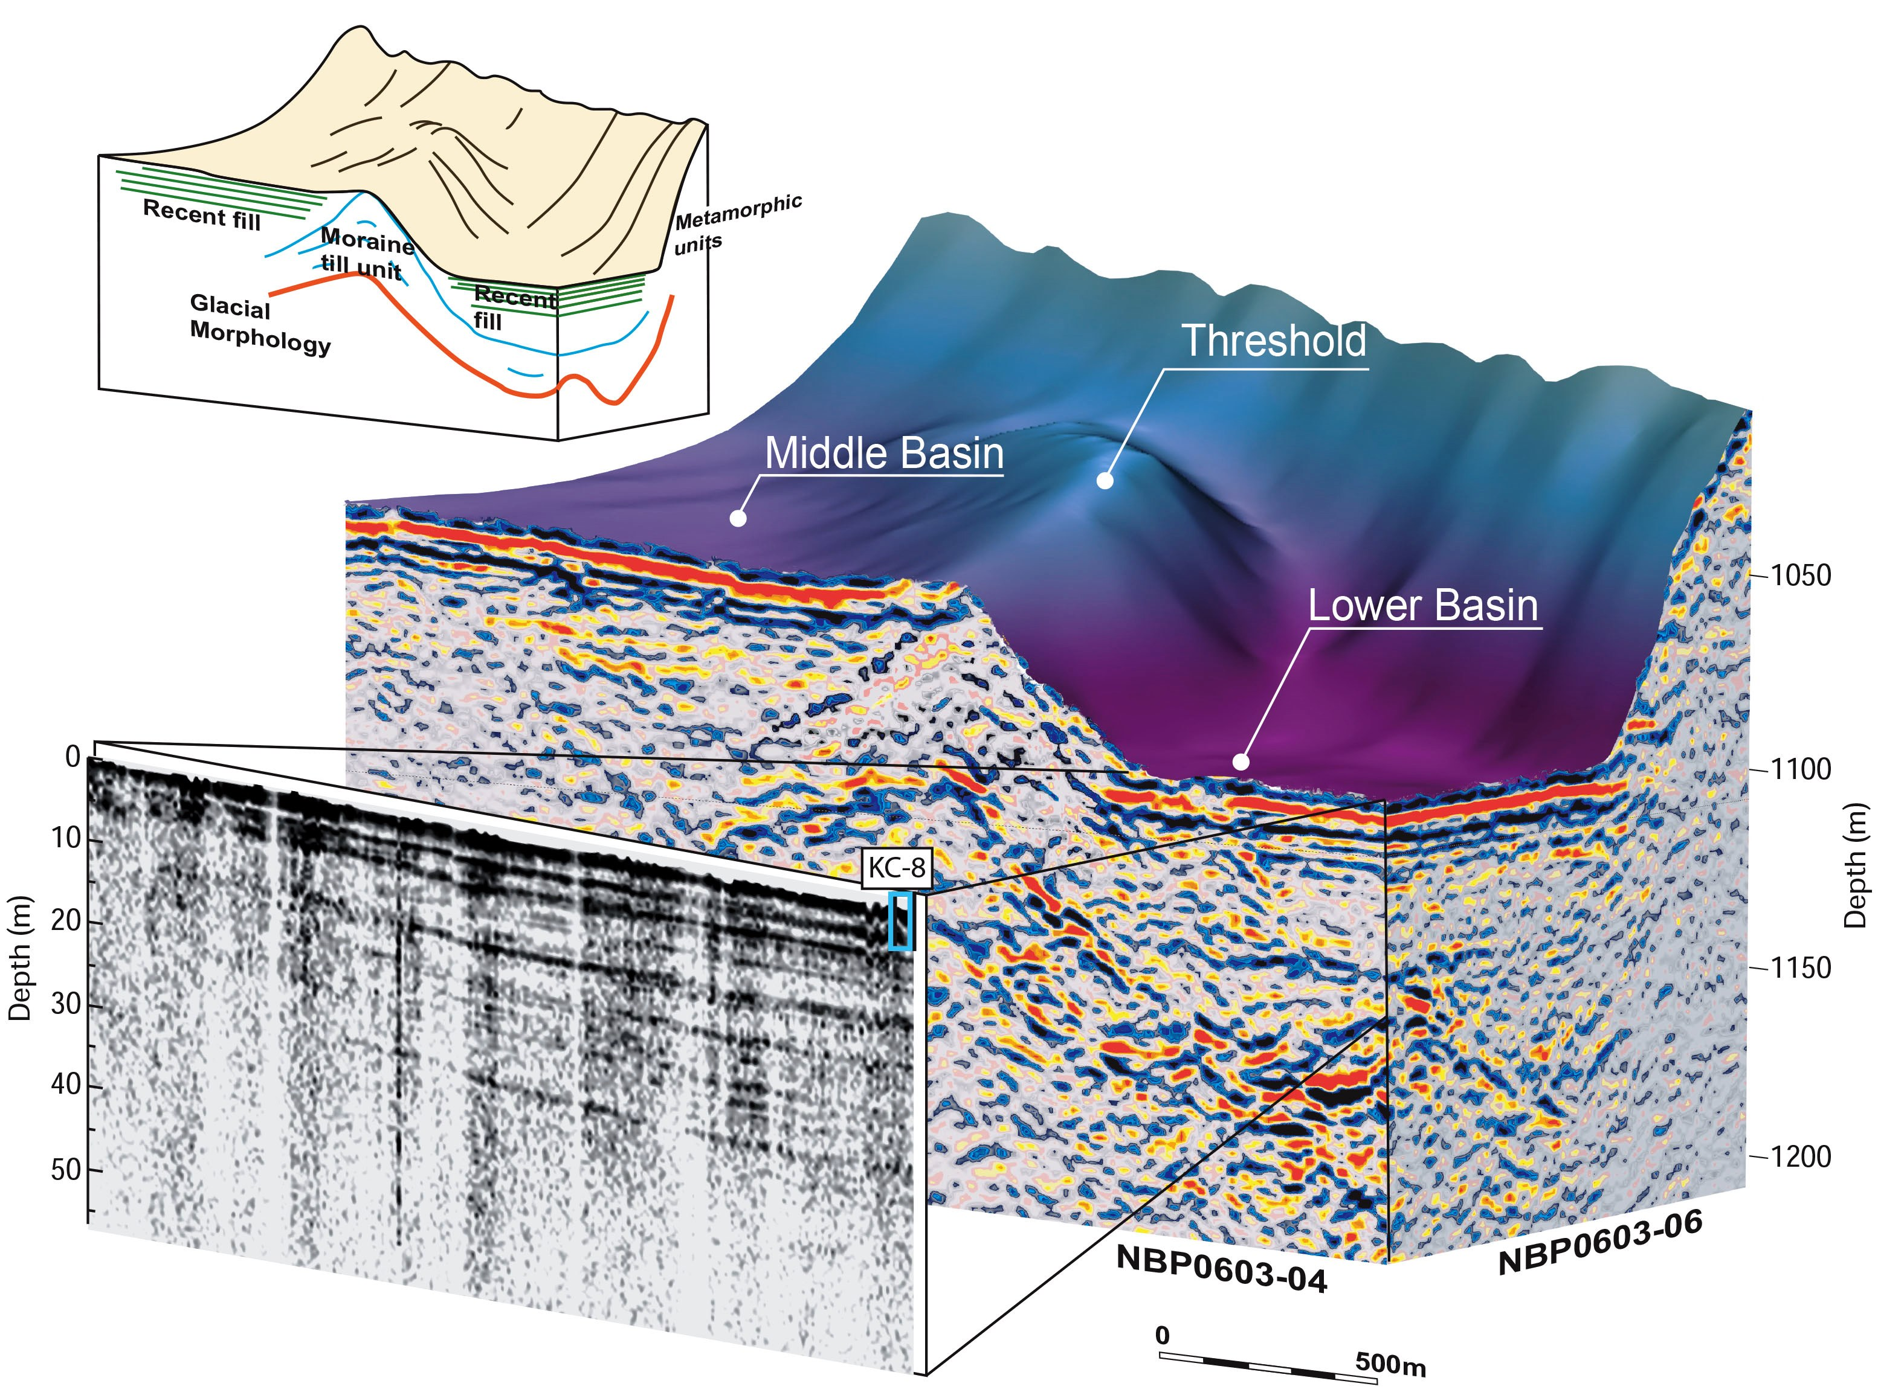

Fig. 4. Three-dimensional view of seismic reflection data and multibeam bathymetry from Crane Fjord. Seismic line locations are shown in the inset of Fig. 1. Colored reflectors in block diagram are from GI-seismic reflection and gray scale panel is from 3.5 kHz CHIRP sub-bottom system. Line drawing inset (top left) shows interpretation of layered and chaotic reflectors.

